Weekly Worksheet Solutions

Student Name: Niraj Poudel

Week Number: 3

Worksheet No / Name:4/ CIS016-1 - Principles of Programming / CIS096-1 – Principles of Programming and Data Structures / PAT001-1 – Principles of Programming - 2019/2020 Exercise Sheet 3

Exercise No 1 /:

Commented Code

import java.util.\*;

public class Car{

// The properties of a car

String model; // the car model

String colour; // the car color

int numOfPassengers; // number of passengers in the car

double amountOfGas; // the amount of gas in the car

// Constructor of a car object. This constructor takes 2 parameters( mod and col) to set the model and the colour of the particular car object.

public Car(String mod, String col, double gas, int passengers)

{

model = mod;

colour = col;

amountOfGas = gas;

numOfPassengers = passengers;

}

// Initialising the values

public void initialise()

{

numOfPassengers = 0;

amountOfGas = 16.5;

}

// Sets the amount of gas. This method changes the amount of gas property of the object, but does not return anything.

public void setAmountOfGas(double amount) {

amountOfGas = amount;

}

// Gets the current amount of gas. This method returns the current amount of gas as a double value.

public double getAmountOfGas()

{

return amountOfGas;

}

// This adds a passenger to car.

public void addPassenger() {

numOfPassengers++;

}

// This removes a passenger from your car.

public void removePassenger() {

numOfPassengers--;

}

// This returns the current number of passengers as an integer value.

public int getNumOfPassengers() {

return numOfPassengers;

}

// This returns the model of the car as a String object

public String getModel() {

return model;

}

// This returns the colour of the car as a String object

public String getColour() {

return colour;

}

public static void main(String[] args)

{

//initialise Scanner object

Scanner scannerObject = new Scanner(System.in);

//requesting string value from user

System.out.println("Hello! Please enter your car model");

//read 1 string

String modelInput = scannerObject.next();

//requesting string value from user

System.out.println("Now insert your car colour");

//read 1 string

String colourInput = scannerObject.next();

//result values input by user

System.out.println("You said your car model is a "+modelInput+", and its colour is "

+colourInput+".");

//request a value from user

System.out.println("What is the amount of gas in your car? (Enter the amount in litres)");

double gasInput = scannerObject.nextDouble();

System.out.println("Thank you! How many passengers do you have in the car?");

int passengerInput = scannerObject.nextInt();

// Create a new Car object and initialise it using values from user

Car myCar = new Car(modelInput, colourInput, gasInput, passengerInput);

// myCar.initialise();

System.out.println("Your car is a " + myCar.getModel()

+ " and it is " + myCar.getColour() + ".");

// Get and print the amount of gas

double gasAmount = myCar.getAmountOfGas();

System.out.println("The current amount of gas is " + gasAmount + " litres.");

// Add and print a new passenger

myCar.addPassenger(); // a new passenger

myCar.addPassenger(); // and another one

System.out.println("Two passengers joined your car");

int passengers = myCar.getNumOfPassengers();

System.out.println("Your car carries " + passengers

+ " passengers right now.");

// Refill the tank, print new value

myCar.setAmountOfGas(gasAmount + 30); // fill the tank

gasAmount = myCar.getAmountOfGas();

System.out.print("You refilled your car! "); // note the use of print()

System.out.println("Now the current amount of gas is "

+ gasAmount + " litres.");

// Remove one passenger, print updated number of passengers

myCar.removePassenger(); // 1 passenger stepped off

System.out.println("A passenger got out of the car");

passengers = myCar.getNumOfPassengers();

System.out.println("Your car carries " + passengers

+ " passengers right now.");

}

}

Evidence of Testing

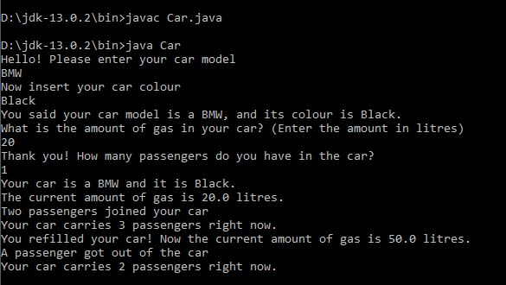

Explanation / Discussion of Solution

Exercise No 2 / Student class:

Commented code

import java.util.\*;

public class Student{

// The properties of a student

int studentID;//student ID

String studentName;//student name

int studentLevel;// Student level of study

//Constructor of a student object takes 3 parameters as values to initialise the particular student object

public Student(int id, String name, int level)

{

studentID = id;

studentName = name;

studentLevel = level;

}

//method to get ID information

public int getID()

{

return studentID;

}

//method to get student name

public String getName()

{

return studentName;

}

//method to get student level

public int getLevel()

{

return studentLevel;

}

//method to calculate grade average

public double gradeCalc (double grd1, double grd2, double grd3, double grd4, double grd5)

{

double average = (grd1 + grd2 + grd3 + grd4 + grd5) / 5;

return average;

}

//main method

public static void main(String[] args)

{

//initialise scanner object

Scanner keyboardInput = new Scanner(System.in);

//request values from user

System.out.println("Hello! Welcome to the University!");

System.out.println("Please enter your name:");

String nameInput = keyboardInput.nextLine();

System.out.println("What is your student ID?");

int idInput = keyboardInput.nextInt();

System.out.println("Thank you! What is your level of study?");

int levelInput = keyboardInput.nextInt();

//create a new instance of student and initialise it using values given

Student newStudent = new Student (idInput, nameInput, levelInput);

//echo back input values

System.out.println("Your ID is: "+newStudent.getID()+

". Your name is: "+newStudent.getName()+

", and your level of study is: "+newStudent.getLevel());

//request student grades

System.out.println("Please we would like to know your grades");

System.out.println("Insert first grade");

double grade1 = keyboardInput.nextDouble();

System.out.println("Insert second grade");

double grade2 = keyboardInput.nextDouble();

System.out.println("Insert third grade");

double grade3 = keyboardInput.nextDouble();

System.out.println("Insert fourth grade");

double grade4 = keyboardInput.nextDouble();

System.out.println("Insert fifth grade");

double grade5 = keyboardInput.nextDouble();

double average = newStudent.gradeCalc(grade1, grade2, grade3, grade4, grade5);

System.out.print("The average of your grades so far is ");

System.out.print("The average of your grades so far is ");

System.out.printf("%5.2f",average);

System.out.print(".");

}

}

Evidence of Testing

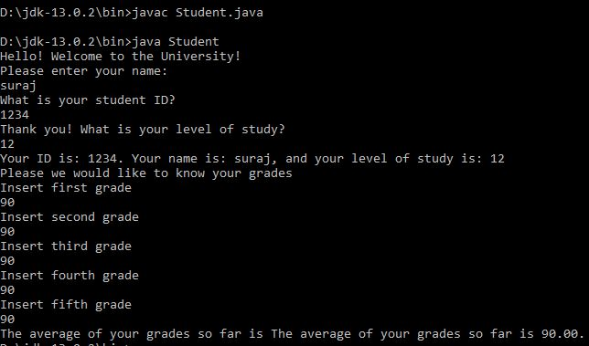

Explanation / Discussion of Solution